**Experiment 2**

**Aim:** Creating and attaching a persistent volume in docker.

Currently the storage that docker uses is ephemeral which means that as soon as the container is deleted the data inside is also deleted.

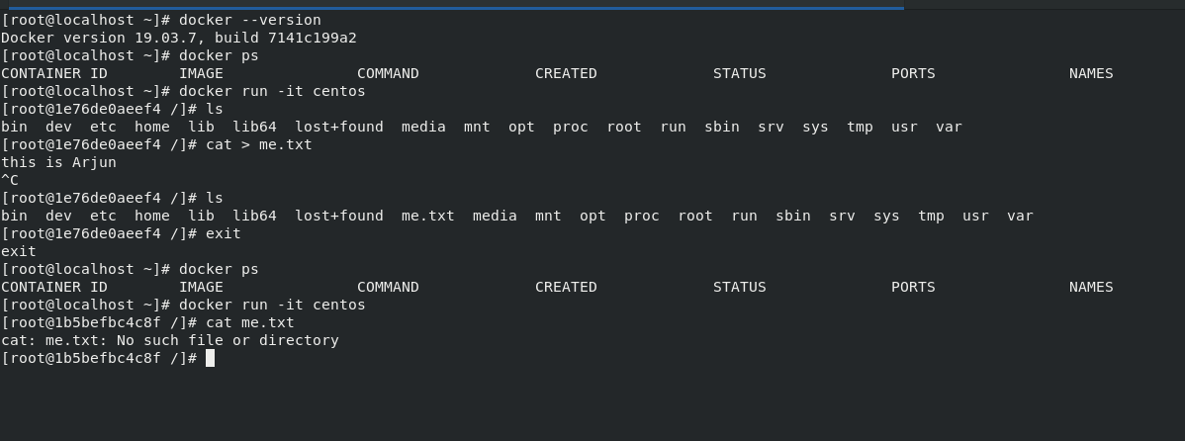

To make the data permanent we create a volume and attach it with the containers. Create the volume using the **‘docker voume create’** command.

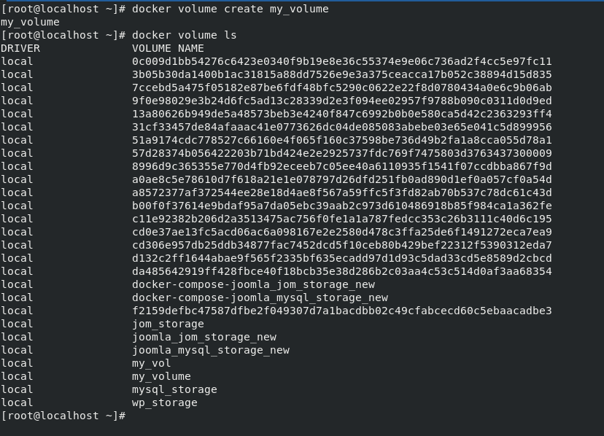

Inspect the volume using the **‘docker volume inspect’** command.

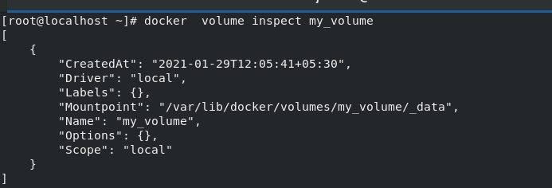

Attaching the volume while running the container using the –v option.

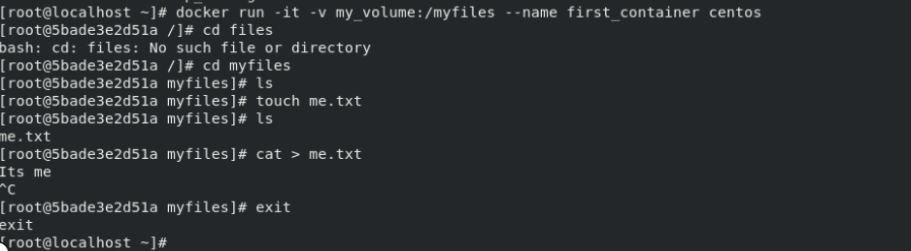

Now as soon as we exit the container is stopped which can be seen with the **‘docker ps’** command as well. Now attaching the same volume in another container and it can be seen that the files and the data are not deleted which proves that the data has become persistent.

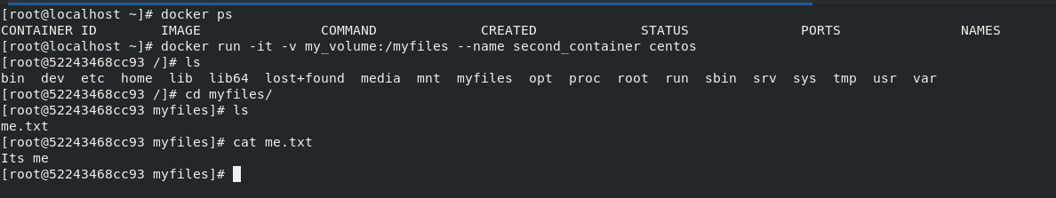

Submitted by:

Arjun Rekhi

500068109

R171218028